**SIMULATION OF A 500 WATTS AUDIO AMPLIFIER**

**CHAPTER ONE**

**INTRODUCTION**

**1.1 Background of the Study**

An amplifier is a device that increases the strength of an electrical signal by drawing energy from a separated source to that of the signal. The original device used in electronic amplification was value in which the cathode-anode current was varied in accordance with the low-voltage discovered FCS design which many contain the complete amplifier and other electronic device in one single chip. The ratio of the output amplitude (of P.D or current) of an amplifier (or stages of an amplifier) to the corresponding input amplitude is called the gain to amplifier.

Amplifiers transmitters makes at possible to keep radio in contact with space probes millions of miles from earth and in airship permits navigators to obtain precise bearing from distant ground-based station.

An amplifier is used to raise every audio signal to power level enough to drive two loudspeakers without introducing extra distortion e.g. Stereos and public address system to convert a few muvolts to signal tonal.

In all electronics equipment e.g. musical instruments radio receivers and transmitter, telephone network e.t.c. the input signal are converted into electrical signal for the purpose of transmission, over a long distance converted back to its original sing for reception. (Hoffman 2020).

An amplifier is also used to increase weak audio signal to power level high enough to drive a loudspeaker without introducing extra distortion. The device use for converting energy from one form to another is called transducer. A microphone is used to convert sound energy to electrical energy while loudspeaker converts electrical energy to sound energy.

The most important properties of an amplifier are at gain of its input impedance, and its frequency response. These are described as follows: -

Voltage Gain: - The voltage gain of an amplifier is define as C.V.

**The Input Impedance:** This is the impedance at the amplifier, it describe the loading effects of the amplifier when impeded on a signal source (input) as the current. Voltage or driving force where current or voltage is applied to the circuit or device.

**The Output Impedance:-** as the current voltage or response from a circuit or a device. The frequency response of the amplifier: This describes the performance or function of the input and signal of the amplifier.

**1.2 Statement of the Problem**

In everyday life most signal ted into input device are generally low the frequency range of human voice is from 20-400hz which lies within the audible range of 20-200hz in human voice, (Mouch out 1961).

Variation in human voice can be converted into corresponding variation in electric current with the help of microphone converted to an amplifier which amplifier the sound to a higher level.

Sometimes, most audio signal strength is very weak and cannot produce high radio frequency signal hence the need for amplifier arices, than audio signal is amplified by pre-amplifier whose output is fed into the power amplifier and then to loudspeaker which reproduces the original sound (Wronski 1967).

**1.3 Aim and Objectives of the Study**

The aim of this project is to construct a 500 watt audio amplifier using electronic component as IC, Resistors, Capacitor and audio amplifier is constructed.

To compare the theory told in class with the practical aspect.

To know various type of electronic components.

* 1. **Significant of the Study**

The significant of the study is to construct and test a 500 watt audio amplifier using component such as (IC, Resister, Capacitor, e.t.c.) providing a devies that a practical amplifier low signal to high sign,which can be use in various place of applications.

* 1. **Scope of the Study**

This work is to construct a 500 watt audio amplifier with a general purpose on a 20v supply and about 500 watts can be obtained. Mainly use for amplification purpose in audio system.

**CHAPTER TWO**

**REVIEW OF RELATED LITERATURE**

**2.1 Historical Background**

This chapter reviews the work of other authors on the same subject (i.e Audio Amplifier).

Anih in 2004 designed and construct a 4-transistor utility audio amplifier delivering 100watts it was based on four transistor and other discrete components. It made use to discrete components and 4.5-volt dc supply; the amplifier has a power isolation circuit and band width to reduce-oscillation and motor boating. The values are particularly critical and modest deviation from the indicated values will not significantly degrade the performance. Thus this 4-transistor utility audio amplifier was designed using Tip 41, Tip 42, Bc 554 and Bc 555 which are connected in such a way as to yield an amplified output. (William in 1995, also designed and constructed a class AB audio amplifier, however, the class AB audio amplifier has been designed for maximum input signal of about 50mv for signal larger than 10k volume control which acts as potential divider a pre-amplifier will be required of the valve of the 10k feedback the amplifier again above 101 (the ratio of (R3  R5 )/ R3). Henry in 2002 also designed and constructed a class B audio amplifier the project was an audio amplifier suitable for amplifying the output signal from a small radio, table player, CD player or any other source of audio signal, for stereo operation, two identical amplifier must be with, one for the left channel and the other for the right channel. To obtain an input signal for this amplifier to amplify just connect it to the output of the audio device (Thomas 2020)

This particular project was constructed using a TDA 2003 (IC) and other discrete components which is use in the amplification of audio signals from the frequency range (of 20-400hz to 20-200hz) human voice to leering range respectively.

The designed was made with components that can with-stand high voltage, independence e.t.c, the 30watts audio signal amplifier is use to boost low frequency audio signal to signal that can power the loudspeaker.

**2.2 Audio Amplifier**

Pre-amplifier are audio amplifier with less than 50mw in the output power .pre-amplifier are optimized for low noise because they are used at the end of the audio system where they are amplifier weak signal photograph cartridge magnitude tab head microphone and 50 on an example of a IC pre-amplifier is TDA 2003 with a five pins a low noise deals pre-amplifiers each amplifier completely independent of the other. The TDA2003 has a voltage gain of 112, and 10v power band with 75HZ. If operate the positive supply 40v its input impedance is look and it output impedance 1500(Otala 2010)

**2.2.1 TDA 2003 Audio Amplifier**

This is a 30watt mono amplifier module using the TDA 2003 semi-conductor. It will operate base on 12v DC since current drain is any 4ma if the LED is not used. it can operate on 12v DC it requires heat sink for normally used the input and output are grounded (lami, 2015)

**2.3 Low power amplifier**

There are only few external components then most of the necessary circuitry is the signal input capacitor which blocks any DC that might be present on the input (2 maintains DC that might level in the gain adjustable input level).

The gain is adjustable from 20-200 i.e 26-46db. The IC gain is kept as low as possible to achieve full output with the input of the potentiometer and signal source of maximum. All the gain provided by the amplifier will reduce the signal to noise ratio by a similar amount since the equivalent input noise is constant (Pandey etal. 2015).

**2.4 Class AB Audio amplifier**

The power module of class AB audio power amplifier being designed for maximum input signal of about 50mvfor signal larger than this the volume control art its potential the input and present over being.

For smaller signal, a pre-amplifier will be require or increase the amplifier gain above (Tremain 2019)

**2.5 Voltage current and power amplifier**

An amplifier is usually meant to amplify either voltage current or power for example in cascaded vacuum amplifier the function of each of the stage except the least one is to provide a voltage that drives the stage than these stage are called voltage amplifier even through their current and power gain is larger (Cyrus 2008)

**2.6 Amplifier again**

Then the gain of amplifier be said to be a relationship that exist between the signal measured at the output. These are three different kinds of amplifier gain voltage gain (AV) current gain (AI) connect gain (AI) and power gain (AP) and example of these are amplifier gain of the input signal voltage amplifier gain, current amplifier gain and power amplifier gain.(Bonov 2019)

**2.7 Power Amplifier**

Small are generally referred to as amplifier they convert a small input voltage into a much large output voltage sometimes an amplifier is require to drive a motor or input land speaker and for these types of amplification were switching current are needed voltage amplifier gain.

Voltage gain (AV) = ---- (1)

Current Amplifier

Current gain (AI) ------ (2)

Power amplifier gain

Power gain (AP) = AV x AI

The power gain of the amplifier can also be expressed in decibels (db) which is the logarithms until of measure. The DC power gain of an amplifier is equal to ten times the common log of the output to input ratio, where as voltage and current gain are 20watts the log of the ratio also the positive value of DB represents a gain and negative value of DB represents a loss with the amplifier for example an amplifier gain of 3db indicate that the output has doubled (Becqueral 1839).

In view of the invention between 1845 and 1849 made by Fleming and English physicist and an engineer, Benjamin Tasco on a two electrode radio rectifier which was the first electronic tube called diode (triode.en.wikipedia.org). A triode is an electronic [amplifying](https://en.wikipedia.org/wiki/Amplifier) [vacuum tube](https://en.wikipedia.org/wiki/Vacuum_tube) (or valve in British English) consisting of three [electrodes](https://en.wikipedia.org/wiki/Electrode) inside an evacuated glass envelope: a heated [filament](https://en.wikipedia.org/wiki/Electrical_filament) or [cathode](https://en.wikipedia.org/wiki/Cathode), a [grid](https://en.wikipedia.org/wiki/Control_grid), and a [plate](https://en.wikipedia.org/wiki/Plate_electrode) ([anode](https://en.wikipedia.org/wiki/Anode)). Invented in 1906 by [Lee De Forest](https://en.wikipedia.org/wiki/Lee_De_Forest) by adding a grid to the [Fleming valve](https://en.wikipedia.org/wiki/Fleming_valve), the triode was the first [electronic amplification](https://en.wikipedia.org/wiki/Electronic_amplifier) device and the ancestor of other types of vacuum tubes such as the [tetrode](https://en.wikipedia.org/wiki/Tetrode) and [pentode](https://en.wikipedia.org/wiki/Pentode). Its invention founded the [electronics](https://en.wikipedia.org/wiki/Electronics) age, making possible amplified [radio technology](https://en.wikipedia.org/wiki/Radio_technology) and long-distance [telephony](https://en.wikipedia.org/wiki/Telephony). Triodes were widely used in [consumer electronics](https://en.wikipedia.org/wiki/Consumer_electronics) devices such as radios and televisions until the 1970s, when [transistors](https://en.wikipedia.org/wiki/Transistor) replaced them. Today, their main remaining use is in high-power [RF](https://en.wikipedia.org/wiki/Radio_frequency) amplifiers in [radio transmitters](https://en.wikipedia.org/wiki/Transmitter) and industrial RF heating devices. (https://en.wikipedia.org/wiki/Triode)

The triode is a three terminal devices with its control grid that can modulate the flow of electrons from the filament to the plate. The triode vacuum amplifier was used to make the first AM radio the triode is used as an electronic signal amplifier. This is the basis for most electronic equipment. (https://en.wikipedia.org/wiki/Triode)

The Audion was an electronic amplifying [vacuum tube](https://en.wikipedia.org/wiki/Vacuum_tube) invented by American electrical engineer [Lee De Forest](https://en.wikipedia.org/wiki/Lee_De_Forest) in 1906. It was the first [triode](https://en.wikipedia.org/wiki/Triode), consisting of a partially evacuated glass tube containing three [electrodes](https://en.wikipedia.org/wiki/Electrode); a heated [filament](https://en.wikipedia.org/wiki/Electrical_filament), a [grid](https://en.wikipedia.org/wiki/Control_grid), and a [plate](https://en.wikipedia.org/wiki/Plate_electrode). It is important in the [history of technology](https://en.wikipedia.org/wiki/History_of_technology) because it was the first widely used electrical device which could [amplify](https://en.wikipedia.org/wiki/Amplifier); a small electrical signal applied to the grid could control a larger current flowing from the filament to plate. (https://en.wikipedia.org/wiki/Audion)

Harold S. Blacks first experiments in the field of negative feedback circuitry were done in 1927, he eventually proved the principles that gave rise to the negative feedback amplifier, one of the most important discoveries in the communication field ([www.fundinguniverse.com](http://www.fundinguniverse.com/)/companyhistories).

In 1967, the MC 2505 was the first separate solid state power amplifier made by Mc-intosh. This amplifier was a major stop in Mc-intosh amplifier history and introduced many features still used in Mc-Intosh amplifiers today. In 1973 forward designed and developed solid state high power, high efficiency power amplifier circuitry for spacecraft transponder transmitters. [www.fundinguniverse.com](http://www.fundinguniverse.com/)/companyhistories)

Early audio amplifiers were based on vacuum tubes also known as valves and some of these achieved notably high quality e.g. the Williamson amplifier of 1947 -1949. Most audio amplifiers are based on solid state devices such as transistors e.g. Bi – Polar junction transistors (BJTs), Field Effect transistors (FETs), Metal Oxide Silicon Field Effect Transistor (MOs FETs) and integrated circuits (ICs) which save space, due to its small size. Also the power consumption is less. In a case where heart dissipation becomes unnecessary heat sink is used. ([www.crownaudio.com](http://www.crownaudio.com/) /history.htm)

In this project an IC STK 4050v was used in the pre-amplification stage and power amplifier stage, which boosts up a small audio signal that comes from the microphone.

**CHAPTER THREE**

**MATERIAL AND METHODS**

**3.1 Materials**

The material used in this research work were purchase were other were locally sourced within the department.

Materials that were purchase includes:

1. Audio jack pm-1
2. TDA 2030 IC-1
3. Resistor-100k(3), 4.7k (1) 10 ohm (1)
4. Capacitor -100mf (1), 0.1mf (2),2.2mf (2),22mf(1)
5. Diode-in 4007 (1)
6. Speaker (1)
7. Battery-12v (I used smps)
8. 22k variable resistor-1 (To adjust volume mf needed).

While locally sourced are:

1. Transformers
2. Diode
3. Resistors
4. Capacitors

**3.2 Methodology**

**Power supply**

**Input signal**

**Pre amplification**

**Amplifier**

**Output**

Fig. 3.1 Block Diagram of an Audio Amplifier

1. **Power Supply**: The power supply distributes the required voltage to the main amplifier circuits.
2. **Input transducer (microphone)**: Is an electronic device, (transducer) that converts sound energy to electrical energy for amplification.
3. **Power Amplifier circuit**: This is the stage that finally amplifies the signal to its maximum power output to drive the speaker.
4. **Output Transducer (loudspeaker)**: This is the transducer that converts electrical energy to sound energy.

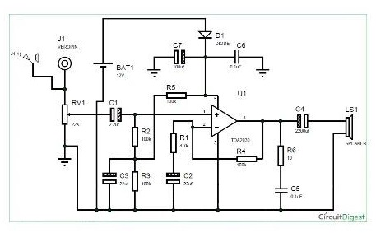

Figure 3.2: Schematic Circuit Diagram of 500watts Amplifier.

**3.2 Methods**

The above is the schematic circuit diagram of TDA2030 based amplifier circuit. The input signal was through the input J1 to Resistor R5 to the ground. The negative terminal of the battery or AC source were connected directly to the negative terminal of the operational amplifier and the positive terminal to the positive terminal of the diode D1 to the positive terminal of the op-Am and the C4 was connected across the diode D1 then grounded. The capacitor C1 was connected directly to the resistor R6 across the diode D1 to capacitor C6 then both were grounded. The resistor R1 and R2 are connected in series to the negative terminal of the OP-Am and the capacitor C2 and C3 were connected in series to the operational amplifier; the resistor R7 was tab from the negative terminal to the output of the OP-AM, the capacitor C4 and C5 are connected in series across the output of the OP-AM through capacitor C7 to the positive terminal of the output speaker and the negative terminal to the negative terminal of the output speaker.

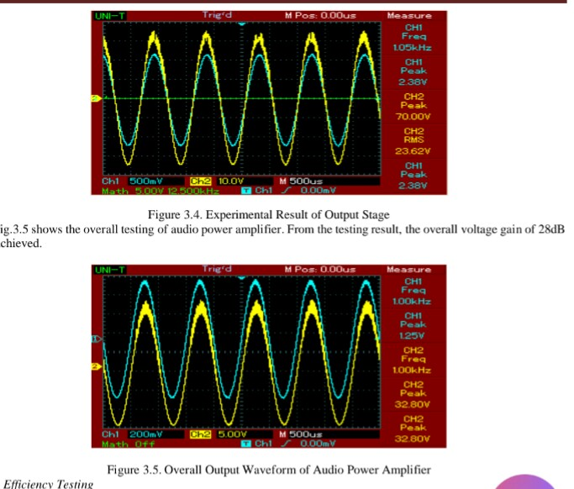

Figure 3.3: Result of the Output stage



Figure 3.4: Overall output waveform of the audio amplifier

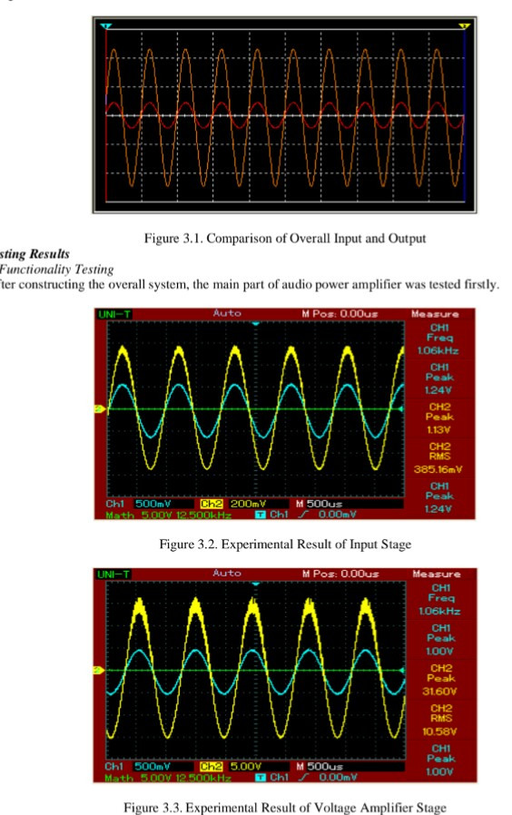

Figure 3.5: Result of the input stage



Figure 3.6: Result of the voltage amplifier stage

**CHAPTER FOUR**

**RESULTS AND DICUSSION**

The simulation of the D.C. load line at the input and output signal amplification was shown in figure a, b and c.

**4.1 Result of the Output of the Project**

Table 4.1 shows the result of the project after performance test was observed that these results obtained is approximately as compared to the predetermine value of the amplifier output signal amplitudes under normal conditions, a small was apply to the device and high signal was obtain at the output

**Table 4.1 Recording result for** **the project**

|  |  |  |  |  |
| --- | --- | --- | --- | --- |
| Test | Input impedance of  Audio input (OHM) | Input impedance of  Audio input (OHM) | | Output impedance  (OHM) |
|  |  |  | |  |
|  |  |  | |  |
|  | With Dc Input Only | | | |
|  | Output Voltage (V) | | Output Current (A) | |
|  | high | | high | |
|  | With DC and Audio Inputs Only | | | |
|  | Output Voltage (V) | | Output Current (A) | |
|  | high | | high | |
|  | With MIC, Audio and DC input | | | |
|  | Output Voltage (V) | | Output current (A) | |
|  | higher | | higher | |

1. **4.1 Graphic of Current Voltage Characteristics**











**4.1.2 AC and DC load lines for the project**

**Fig 4.1** (a) Load line with DC input only

(b) Load lines with DC and Audio input only

(c) Load lines with MIC, Audio and DC inputs.

**4.2 RESULT AND DISCUSSION**

**4.2.1 Performance Test**

After the audio amplifier construction was fulfilled, a performance test was carried out to estimate the reliability of the performance of the project. Thus the performance test was carried out as follow under “MIC and Audio” maximum input respectively.

1. Without input (MIC, audio and the signal).the input impedance of the MIC (microphone)and the audio inputs were recorded.
2. The input impedance was also recorded without any inputs.
3. With dc input only, voltage and current when measured and recorded for comparing the Q-point of the amplifier with the predetermined value.
4. With dc and audio inputs only, the Q-point was determined by recording the increase in output current and decrease in outputs voltage as compared to case iii)
5. With MIC, audio and dc inputs dc the Q-point was determined by recording the slight increase in current and corresponding decrease in voltage as compared to case iv. The above measurement and records were taken after ensuring that every element component involves in the project circuit is at good condition.

Although, before the performance test was taken, a trial test made cotirm the predetermined Q-point to be much superior to the recorded readings, hence under test for individual components, some components confirmed to be liable to the weak performance of the amplifier was change with a newer ones, and the result obtain and recorded as the overall performance of the project was made clear in section 4.2.

**CHAPTER FIVE**

**CONCLUSION AND RECOMMENDATION**

**5.1 Conclusion**

Some audio devices such as radios, microphones, among other, sometimes the maximum sound produce may be restricted to a level that can be considered as “3 week sound reception” depending on the individual users of such device(s) however the sound produced by such device(s) necessitate a research work base on the construction of 500 watt audio amplifier for improving the sound signal level of such devices to level that can be tolerated by a 400hm/30watts loudspeaker specified as the “output loud of this project”.

In addition reliability of this project perform effectively depends chiefly on the effectiveness and the configuration network established by the individual components used in the construction and as well, the different amplification stages contributes on improving the thermal stability as well as yielding a high enough audio signal to drive the loudspeaker. However, the introduction of the negatives feedback loop used for coupling the output back to the input was aimed at moderating or stabilizing the audio output of the amplified from exceeding the level that can be to tolerated by the specified output load for this project.

* 1. **Recommendation**

1. For normal operation of the project, the input voltage has to be more than 15 volt ac
2. The input (MIC/Audio) frequency response most falls within frequency range. (a normal mic)
3. For maximum power to be transferred to the loud speaker, a speaker was specified to be used as the output load of this project.
4. Like any electrical and electronic devices, this project should not be operated in a damped or high humility environment of atmosphere.

**Reference**

Bonor C.P (2021). *Sound Reinforcement System in Reverberant Churches.* New York.

David, B. (2000). *Electronics Devices and Circuits*, 3rd Edition. New Daily.

Davis C. Davis D. (2019). *Sound System engineering* 2nd Ed. Indianapolis. IN:

Douglas, S. (2006). Audio Power Amplifier Design Handbook, Linacre House, Burlington.

George, C. (2003). Operational Amplifier, 5th Edition. Burlington.

Howard W. Sams. http://Cyrus.Audio.com/Product-Achieve/amps/1-integrated-amplifier-all version Cyrus

<https://en.wikipedia.org/wiki/Audion>

<https://en.wikipedia.org/wiki/Triode>

Islam, M., & Chowdhury, H. (2020). DTMF Based Home Appliances Control Using Cell Phone. Dept. of Electrical and Electronic Engineering, *Chittagong University of Engineering and Technology Chittagong,* 43(49), 1-3.

Jagadeeswari, M. & Eli, A. (2019). Control of Electrical Appliances through Voice Commands. *IOSR Journal of Electrical and Electronics Engineering,* 9(1), 13-18.

James, L & Smith, U. (2014). Review of Lightning protection Standard in building in Nigeria. *Journal of Electrical Electronic Engineering*, 9(1), 32-44.

John, B. (2003). Electrical Circuit Theory and Technology, Revised 2nd Edition.

Kaphungkui, N. K. (2019). RF based Remote Control for Home Electrical Appliances. *International journal of innovative research in electrical, electronics, instrumentation and control engineering,* 3(7), 1-3.

Otala, M.; Lammasnlemi, J. (2022). Journal Audio Engneering Society, Vol 28 # 3, March 1980

Ramanan, K. (2000). Functional Electronics, New Daily.

Sendra, A. S. & Smith, K. (2004). Microelectronic Circuits, 5th Edition. New York.

Steven, T. (2005). Electronic Devices and Amplifier Circuits. Prentice Hall, New York.

Thomas T. (2020). Digital Processing for the Digital Age Roland Users Group, Vol. 6 pp. 60 – 62

Tony, R. K. (2009). Lessons in Electric Circuits, Semiconductors, 3(1), 45-62.

Tremain, H. (2021). Audio Cyclopedia 2nd Ed., H.W. Sams, Indianapolis, 1973